**SCRUM - Systematic Customer Resolution Unraveling Meeting.**

Scrum requires a Scrum Master to foster an environment where:

1. A Product Owner orders the work for a complex problem into a Product Backlog.
2. The Scrum Team turns a selection of the work into an Increment of value during a Sprint.
3. The Scrum Team and its stakeholders inspect the results and adjust for the next Sprint.
4. Repeat

Changes for fast executions

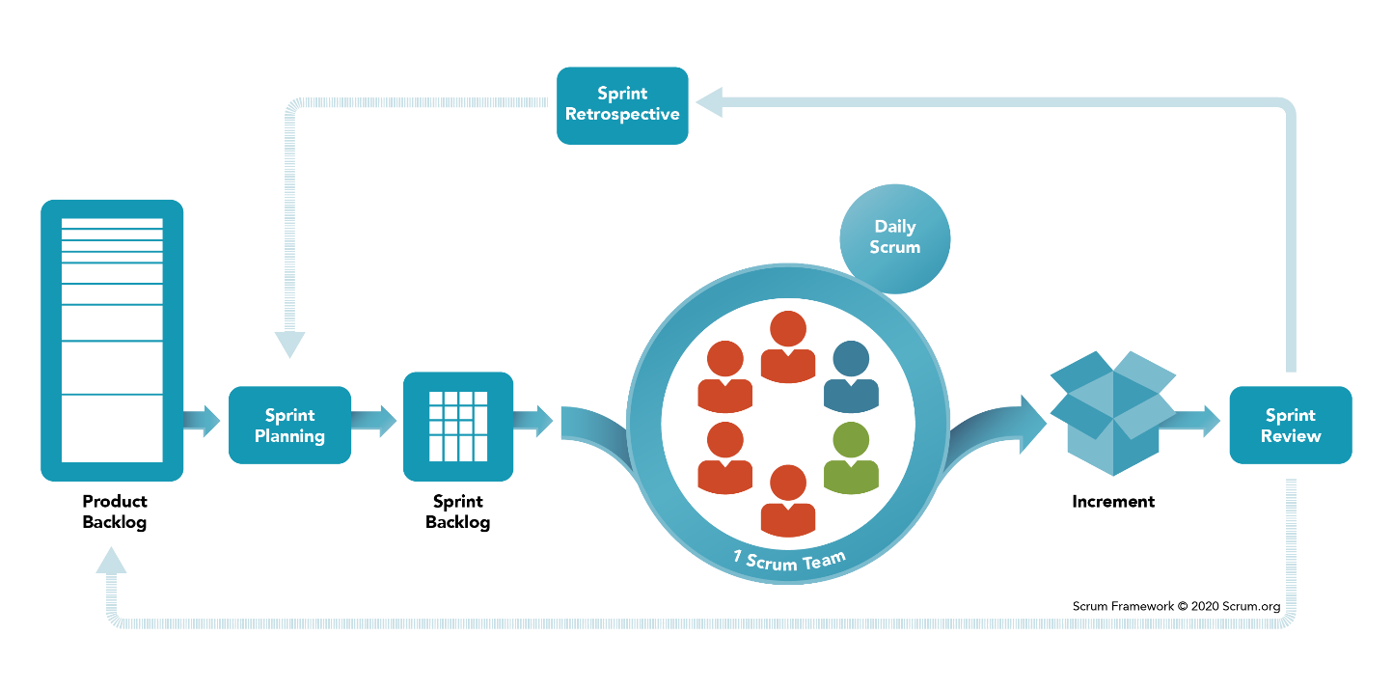

Prioritize feature of products

Presentation

Prioritize feature of sprint

Potentially shippable product

Daily backlogs and updates.

***Scrum Ceremonies***

Sprint planning meeting

Sprint Retrospective

Daily Scrum

Sprint Review

**User Acceptance Testing (UAT)**

**Sprint planning meeting**

Objective- Selecting the set of product backlog items which has to be delivered during the current sprint.

**Focus**- what is to be built during the sprint | How the team will build it

**Sprint**

Whole process is break under smaller pieces called sprint

Takes some weeks to build.

Sprint is potentially shippable product

Several incremental releases called Sprint

[PLAN | BUILD | TEST | REVIEW] SPRINT1/ SPRINT 2 … SPRINT N **Agile framework**

[PLAN | BUILD | TEST | REVIEW| RELEASE] in **DevOps framework**

**3 Roles**

1. Product owner- Give Detailed about product (not necessary the client i.e., product manager)
2. Scrum Master- (Team Leader) Manage the flow of Scrum
3. Team- Developer, Tester, Quality Analyzer (cross functioning members)

**3 Artifacts**

1. Product backlog- prioritize list of feature User Stories

User Stories- describing the feature set

1. Sprint Backlog- highest priority user stories for next sprint
2. Burndown chart- Show progress during sprint completion of tasks.

***Reference***= <https://www.youtube.com/watch?v=9TycLR0TqFA>